ZEBRA BATTERY

Winflash version 1.16r2 Installation notes

Version : 1.16r2
Date : 10.12.2010
Author : AB

Winflash has to be installed on a PC after installation of HW interface.
Included in the folder CDROM:\DiagnosticKitxx\WinFlash\Ver_116r2 there are:
1_winflash_116r2.exe, the installation package for STW Winflash116r2, and
2_STW_DLL_WF.zip with STW DLL interfaces and INI files to handle HW interface: PeakCAN-USB, Vector CANcardXL, CANcardX, CANpari.
3_WinflashTroubleshooting.txt, with some suggestion about problems that can be occurred.

In order to install Winflash, please follow the steps below:
- Verify that in “Control Panel” the applet “CAN Hardware” has “Active Device” set to “USB”, as showed below. Otherwise, please set USB as Active Device and press Apply button.

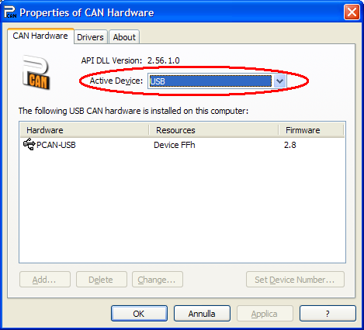

- Execute 1_winflash_116r2.exe.
  - Select Remove if another previous version is already installed and then run again 1_winflash_116r2.exe.
  - Press Next button twice.
  - Press Yes to confirm the license.
  - Press Next to confirm as installation path C:\Programmi\STW\KEFEX Winflash.
  - Select Compact installation and then press Next button.
  - Select Configure Manually option and then press Next.
  - Press OK to complete the installation.
- Decompres 2_STW_DLL_WF.zip into C:\Programmi\STW\KEFEX Winflash\Winflash.
  - Press Yes to All in order to replace all existing files.
  - Now in C:\Programmi\STW\KEFEX Winflash\ Winflash there are all the files used by Winflash.
- After the installation run Winflash from Start → Programmi → STW → KEFEX WinFlash → Winflash
- And check the following setting:

For VECTOR interface
Comm-DLL: C:\Programmi\STW\KEFEX Winflash\Winflash\stwvec32.dll
Configure: select the used Vector channel.

For PEAK interface
Comm-DLL: C:\Programmi\STW\KEFEX Winflash\Winflash\stwpeak2.dll
Configure: select TestNet as Setup network with 125K bit rate and 11bit ID to receive at 0x000/0x7FF
Local ID = don’t care
Company ID = MD
Send ID= 81
Bitrate= 125K usually
Type of HexFile= C application (all sectors)
SendResetRQ= disabled
Timing Delay= 500 micro sec
Start Time= 3s usually or higher
Node’s SN = don’t care
Only if you do modifications, save the current configuration as FZSONICK with command File → Save Current Configuration.

To download software on one BMI:
- select Search Node,
- turn on the ignition key when required
- in Windows Results flag the BMI where download
- select Flash node to start the download.
- (Ignore permanently hex/device ID consistency)

At the end of the download:
- Close winflash
- Turn ignition key at off for at least 20sec and then turn on ignition key and leave at on for at least 20sec.

IMPORTANT NOTE:
If an error occurs after search nodes command while PEAK CAN USB hardware is used, please see the file “WinflashTroubleshooting.txt” in the folder “C:\Programmi\STW\KEFEX Winflash\Winflash”.

